StudyChat App
System Architecture & Application Flow
Technical Design Document
Version 1.0 • July 2026

1. Application Overview
StudyChat is a real-time collaborative study platform that combines peer-to-peer group chat with an integrated AI study assistant. Students create or join topic-based study rooms, exchange messages and study material in real time, and can address questions directly to an AI assistant for explanations, summaries, and practice quizzes.

2. Technology Stack
- Frontend (Web): React.js + Vite, Tailwind CSS, Redux Toolkit, Socket.IO client
- Frontend (Mobile): React Native for iOS and Android with offline caching and push notifications
- Backend: Node.js + Express.js REST API behind an API gateway with JWT middleware, rate limiting, and CORS
- Real-time layer: Socket.IO with Redis Pub/Sub adapter for horizontal scaling
- Database: MongoDB Atlas (users, messages, studyRooms, notifications, aiLogs) via Mongoose ODM
- Cache & sessions: Redis (session store, presence tracking, rate-limit counters)
- File storage: AWS S3 with CloudFront CDN for study notes, PDFs, and images
- AI: LLM API (OpenAI / Claude) powering the AI Assistant Service
- Notifications: Firebase Cloud Messaging (push) and SendGrid/SMTP (email)

3. Core Services
- Auth Service — registration, login, bcrypt password hashing, JWT access/refresh tokens
- Chat Service — one-to-one and group messaging, history, read receipts
- Study Room Service — room creation, membership, topics, and shared resources
- AI Assistant Service — prompt construction, LLM calls, doubt solving, quiz and summary generation
- Notification Service — in-app alerts, mentions, email and push dispatch

4. System Architecture Diagram
The architecture is organised into four layers. Clients communicate with the backend over HTTPS (REST) and secure WebSockets (Socket.IO). All traffic enters through a single API gateway that enforces authentication and rate limits before routing to domain services. The data layer separates persistent storage, caching, and file storage, while external services provide AI, push, and email capabilities.
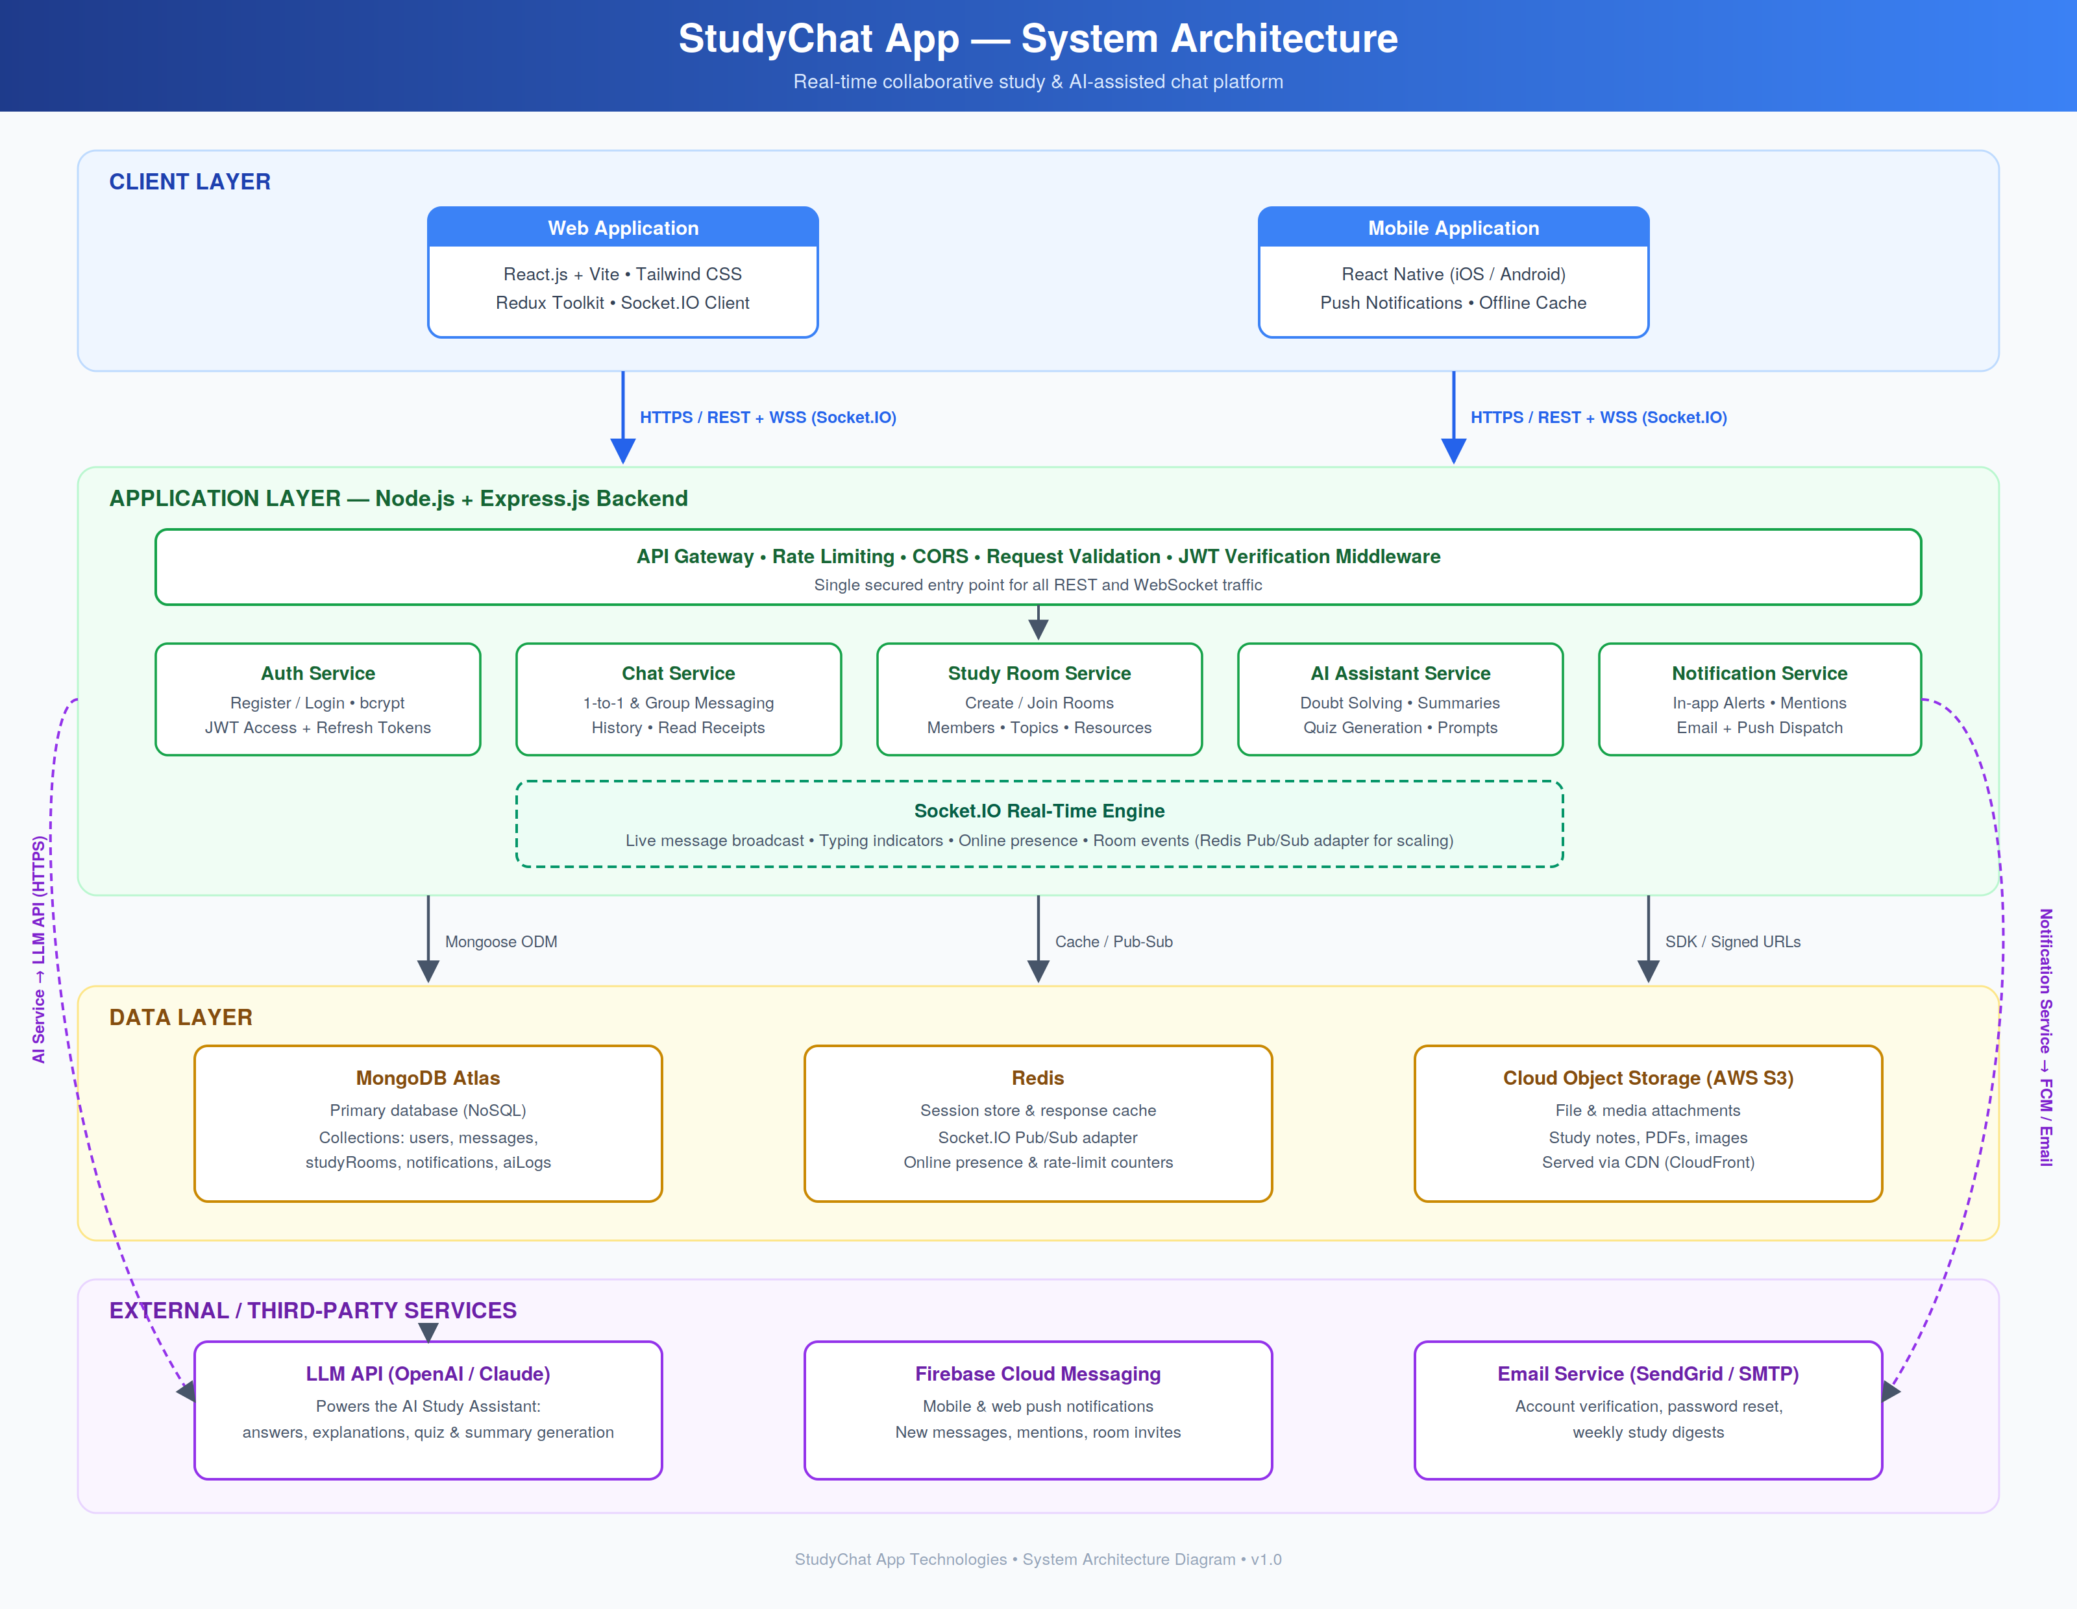

5. Application Flow Chart
The flow below traces the complete user journey: session validation, login/registration with retry on failure, dashboard loading, joining a study room, and the message loop. Each sent message is routed either to peers (persisted in MongoDB and broadcast via Socket.IO, with push notifications for offline members) or to the AI Assistant Service, which calls the LLM API and returns a formatted assistant reply into the same pipeline.
